**FLY ASH**

**HERO**

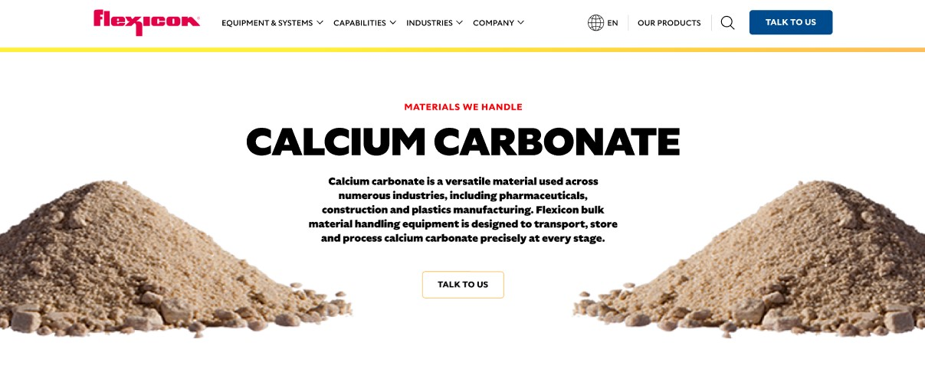

Fly ash is a fine, powder-like material produced during the combustion of pulverized coal in power plants. This versatile material is used in a wide range of products, including countertops, ceiling tiles, kitchenware, and even sports equipment. Flexicon’s bulk material handling systems are specifically designed to transport, store, and process fly ash with precision and efficiency throughout the manufacturing process.

**Button**: Talk To Us

**SHELF #1 - PRODUCT DESCRIPTION**

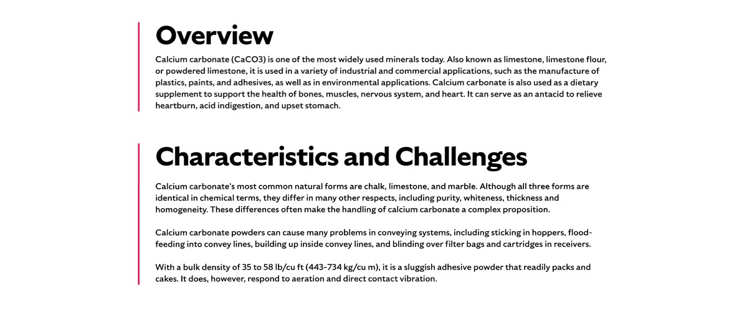

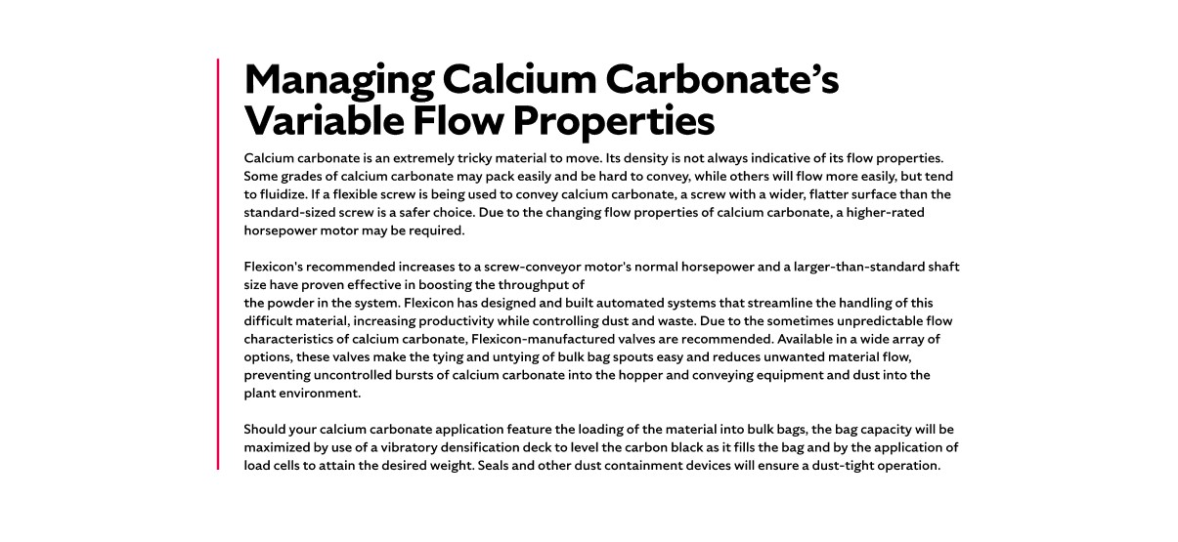

* **Overview**Formed when non-combustible minerals in coal melt at high temperatures and cool into spherical glassy particles, fly ash is produced in two main forms—Class C from lignite or sub-bituminous coal, and Class F from anthracite or bituminous coal. Once captured from flue gases, fly ash can be used for cement and concrete production to structural fills, road base, and waste stabilization. Its incorporation into building materials not only improves performance but also supports sustainability, with significant energy and CO₂ savings.
* **Characteristics and Challenges**Fly ash is a pozzolanic material, meaning it develops cement-like properties when mixed with water. Depending on fuel source and mineral content, it can vary in form but is generally fine, cohesive, abrasive, and aeratable, with a bulk density of about 65 lb/ft³. When used as a partial replacement for Portland cement, it improves durability, reduces water demand, and offers cost savings.

Handling fly ash can be difficult due to its tendency to flood, bridge, rat-hole, or cause excessive wear on conveying equipment, leading to costly downtime and maintenance. Its fine, aeratable nature allows particles to become airborne, increasing the risk of dust exposure and material loss. Effective dust control, sealed conveying systems, and flow-promotion devices are essential to prevent spillage, maintain consistent material flow, and ensure a safe, clean work environment. Additional considerations include controlling moisture levels, preventing clogging in hoppers and lines, and minimizing equipment abrasion caused by the abrasive properties of fly ash.

**SHELF #2 - FLEXICON SOLUTIONS**

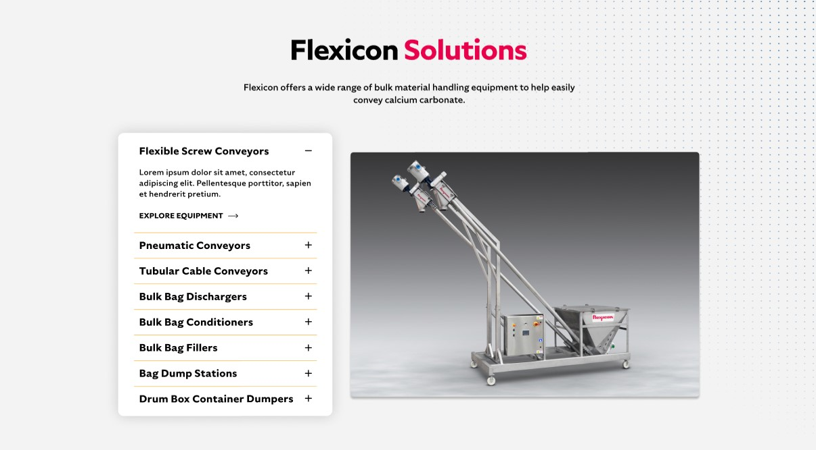

**Flexicon Solutions**

Flexicon offers a wide range of bulk material handling equipment to help easily convey calcium carbonate.

* **Flexible Screw Conveyor**: Moves fly ash gently and consistently while reducing aeration and dust generation.
* **Pneumatic Conveyors**: Transfers fly ash over long distances with controlled airflow and minimal material degradation.
* **Tubular Cable Conveyors**: Encloses and protects fly ash during transit, preventing contamination and dust escape.
* **Bulk Bag Dischargers**: Provides dust-tight unloading with flow-promotion systems for complete bag emptying.
* **Bulk Bag Conditioners**: Loosens compacted fly ash to improve flow and ensure full discharge from bags.
* **Bulk Bag Fillers**: Delivers precise, dust-controlled filling while maximizing bulk bag capacity.
* **Bag Dump Stations**: Offers safe, enclosed manual unloading of fly ash with integrated dust collection.
* **Drum Box Container Dumpers**: Efficiently empties containers into your process while controlling dust emissions.

**SHELF #3: LIFETIME PERFORMANCE GUARANTEE**

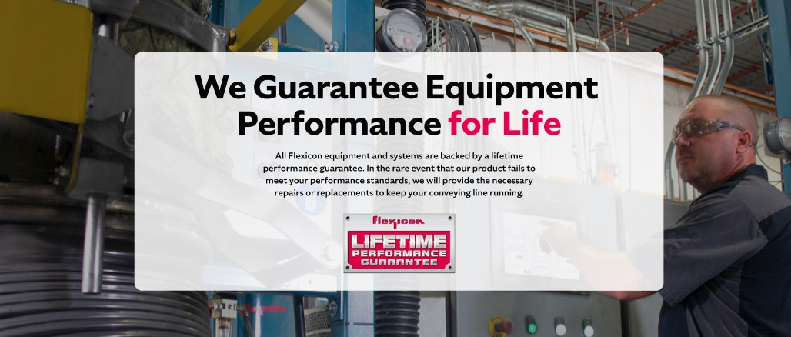

**Lifetime Performance Guarantee**

All Flexicon equipment and systems are backed by a lifetime performance guarantee. In the rare event that our product fails to meet your performance standards, we will provide the necessary repairs or replacements to keep your conveying line running.

**SHELF #4: CASE STUDIES**

